Institute of Grace February 2018 Newsletter
February is the month of Love – Valentine’s Day and Martin Luther King, Jr. Day are both holidays celebrating love: Love for someone most dear and also love for our enemies and ourselves. The Institute of Grace is also all about love, as we seek to love our brothers and sisters and children in the Lord in Haiti by helping them with a good education and by spreading the Good News of Jesus Christ so that their minds will be transformed by Christ. I know my way of thinking has been transformed by my time in Haiti, meeting and working with them.
As 2018 begins, we are once again facing the monthly demand of payroll and feeding support for our growing school. Each month we support 25 teachers and staff who are educating 185 students in Pre-K through 7th grade classes.
This is a recent photo of many of the teachers. Most of them work for just under $100 US per month in challenging conditions.
Teams that go to Merger, Haiti have the opportunity to work in the classrooms with them. We also bring supplies and encouragement for them. We also can support them from afar.
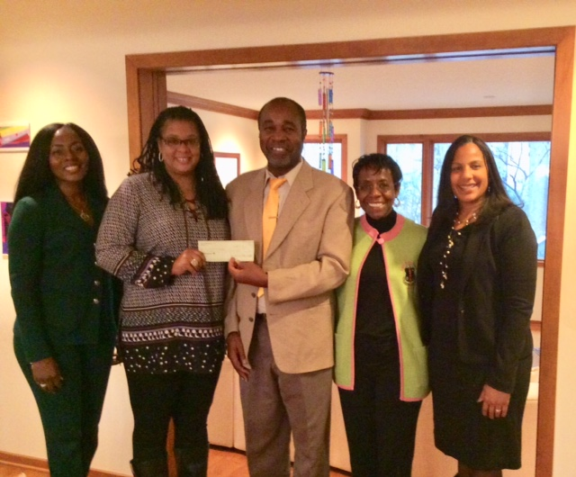
In the center of the picture to the right we have Jean Filostin, the IOG Executive Director, accepting a check of $500 for EGF school support from The Pearl Foundation, Incorporated, which is the charitable affiliate of the Alpha Kappa Alpha Sorority, Incorporated, Iota Lambda Omega Chapter. Jean Lewis, of this Chapter is to the right of Jean. She traveled to Merger in 2017 to meet the teachers and see the school.

We are also striving to expand the clinic with doctors on location and 24-hour care. And there is a group of educators working with the University de la Grace to expand the course offerings in the agricultural, business, and nursing areas. There is so much our partners in Haiti want to do, if the funding becomes available. For more information on this, see our website: http://www.instituteofgrace.org/
February 15th I will be going down to Haiti for a week of working with a group of students in the 2-year certificate program in church leadership conducted by the IOG. This course is a mix of theology, Bible, personal and business principles. I very much enjoy working with these members of churches around Haiti.
While I am there, Kent Hills will be joining me for a week to work on the Solar system for the school computer lab. We are also bringing down the latest version of “Internet in A Box,” donated to EGF by the Bethel Computers for Education out of Warrenton, VA. With this system we can offer realistic computer training and supplement their educational resources. Kent and I will also look at sub-dividing the bottom floor where 4 classes share one large room.
Teams are in planning for April and June. The June team will be June 15-22, 2018 and led by Grace UMC in Gaithersburg, MD. This will be Rev. Jim Miller’s second visit. Pastor Jerome Jones of Church of the Redeemer UMC in Temple Hills is going in April with persons from several churches. This will be Pastor Jerome’s third trip.
As always, we ask you to hold these efforts in prayer and realize that this work would not be possible without the continued support of our U.S. partners. $100 a month will support the teacher for an entire classroom of students, many of whom would be roaming the streets without your help. $10 will feed a student for an entire month.
Every contribution makes a difference for these people. Thanks for your prayers and support!
David Graves
Director of US Operations, Institute of Grace
240 601 0218 davidgraves1982@gmail.com

Contributions can be sent to:
Institute of Grace
P.O. Box 2364
Leesburg, VA 20177

Or contact David Graves for information about setting up a direct contribution.
The IOG employs Haitians in the local communities, and has opportunities for missionaries to work in country. Without contributions from the United States, the school and university would not be able to reach so many students, so funding is a critical component of this ministry.

It may not look like much, but what a difference it makes for 180+ children.
Regular support is still needed for the school budget. One-time gifts and church offerings are a huge blessing, but regular support is what really keeps us going. I’ve attached a sponsorship form, if you would like to be a regular sponsor. You can also save a stamp and email me this information at davidgraves1982@gmail.com
